How to Cite in APA Style

Research Articles:

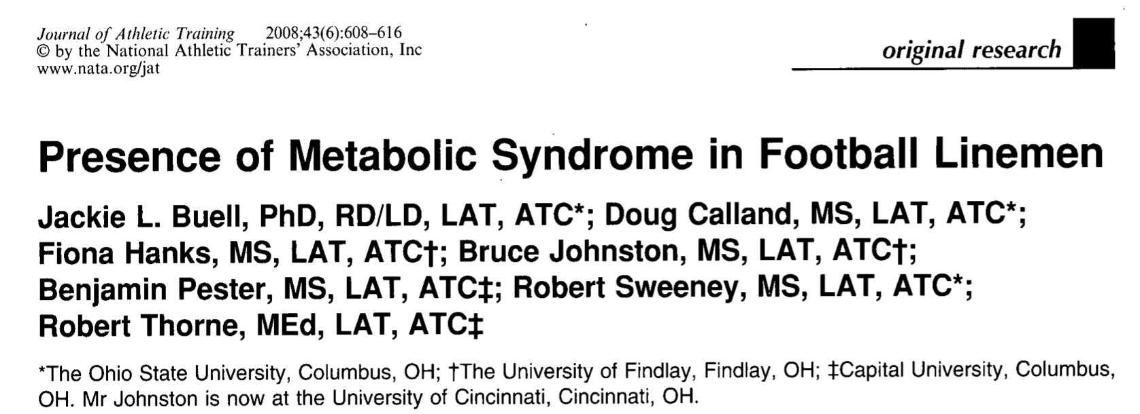
Author (w/ first and middle initials) (year published). Title of research article. Title of journal article was published in, volume number(issue number):pages.

Example:

Buell, J. L., Calland, D., Hanks, F., Johnston, B., Pester, B., Sweeney, R., & Thorne, R.
(2008). Journal of Athletic Training, 43(6):608-616.

Websites:

Author (date published). Article title. Retrieved November 28, 2017 (current date), from url link.

Centers for Disease Control and Prevention (CDC). (2017, August 29). Overweight &
obesity. Retrieved November 12, 2017, from
https://www.cdc.gov/obesity/data/adult.html.
Kirkpatrick, K. (2014, March 03). Fish faceoff: wild salmon vs. farmed salmon.
Retrieved November 17, 2017, from
https://www.cdc.gov/obesity/data/adult.html.

In-text citations:

There are different ways you can do this, and I’ll give you examples based off of the same sentence in the Fish Faceoff article.

1.) According to Kirkpatrick (2014), “A small fillet of wild salmon has 131 fewer calories and half the fat content of the same amount of farmed salmon.”
- This is for when you are using a direct quotation, word-for-word from whatever source you’re using. You absolutely HAVE to have quotation marks and proper citation for this situation otherwise it is considered plagiarism.

2.) According to Kirkpatrick (2014), it could be inferred that wild-caught salmon is healthier than farmed salmon because it contains fewer calories and fat content when compared to the same amount of farm-raised salmon.

3.) It could be inferred that wild-caught salmon is healthier than farmed salmon because it contains fewer calories and fat content when compared to the same amount of farm-raised salmon (Kirkpatrick, 2014).
- Since I am using information in this sentence that is not intuitively known and not my own opinion (even though the beginning part about wild-caught salmon being healthier is my opinion), I HAVE to cite a source here. The fact of wild-caught salmon having fewer calories and fat is from somebody else’s research, so I have to cite them and give them credit. The same logic goes toward number 2; the only difference there is that I began the sentence with citing the author.

When you all paraphrase information from a different source, I want it to look more like numbers 2 and 3. There are still the main facts from the article in the sentence, but it also contains my opinion. Starting to write like this will really improve your formal writing skills.

